Expose Azure Files to HYCU as target
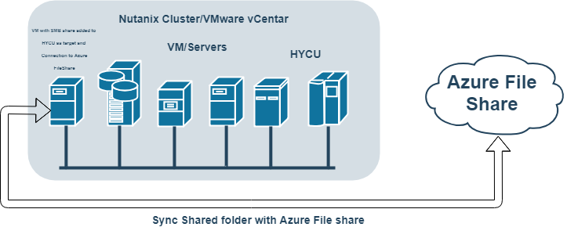

Prerequisites:
- Windows VM (Windows 7,8,10, 2008, 2012, 2016)
- Microsoft Azure account
- Port 445 forwared to Windows VM in both ways
- Shared Folder on Windows VM with enough space for HYCU Full Backup (depends on HYCU second vDisk minimum will be 42 GB)
- Folder Sync Software
NOTE: use CTRL+ left mouse click on video links to open video
IMPORTANT: Watch for uppercase and lowercase letters in command

Contents
STEP 1 – Deploy Windows VM to your Nutanix Cluster/vCenter 4
STEP 2 – Share Folder on Windows VM 5
STEP 3 – Map Azure Files as drive to Windows vm 6
STEP 4 – Download and install File/Folder Sync Software 7
STEP 5 – Set File/Folder Sync software to mirror Shared folder to Azure Files 8

STEP 1 – Deploy Windows VM to your Nutanix Cluster/vCenter

Deploy Windows VM (any Windows will do, 7,8,10, 2008, 2012, 2016). Allocate resources needed for that vm (CPU, ram and most important vDisk size (check HYCU second vDisk size and add it to 10GB what is default primary disk size) example (10GB + 42GB = 52GB) is needed for HYCU Full Backup.

STEP 2 – Share Folder on Windows VM
  - video file

STEP 3 – Map Azure Files as drive to Windows vm
  - video file

STEP 4 – Download and install File/Folder Sync Software
  - video file

STEP 5 – Set File/Folder Sync software to mirror Shared folder to Azure Files
  - video file

